|  |  |
| --- | --- |
| Personal development plan  Jesse van den Broek | PI&V |

Contents

Introduction 2

Professional identity 2

Past experience 2

What drives me 2

Personal quality’s 2

Personal pitfalls 3

Vision 4

Development 5

Previous goals 5

(New) Goals 8

# Introduction

Who am I, and who do I want to be as a designer? How do I see the future, and what influence do I want to have? It is important to have an answer to these questions. It enables one to be able to set clear goals for themselves, but also it gives them a larger understanding about themselves, what drives them, what they want to add to the world.

This document reports my search and development of my own professional identity and vision by setting goals and reflecting on past activities.

# Professional identity

## Past experience

I’ve always enjoyed combining technology together with creativity, as well as applying technology to make stuff. As child I already enjoyed making simple robots with a simple all in one kit and simple instructions. Around 2 years ago I discovered the Arduino, and started programming and building little games and projects. Different small projects like an attempt to build a simple game using Unity or experimenting with building a website always gave me much joy, even though they were often not really in depth.

My goal as designer is to combine these interests together with my will to help people, solve problems and create products.

## What drives me

I really like to either help people, or solve problems. I think this is also my main drive, because if I have a problem to solve, I want to work on it until I found a way to solve it.

As a designer I get a lot of fulfilment and pleasure from making an idea reality. I’ve always enjoyed programming and making stuff work, no matter if it was an Arduino project an easy automation project using python. Seeing your own idea come to real life and facing the challenges that come with it is what I love to do and which also drives me as designer. This also means I’ll have to develop multiple skills in technology and realization like programming and electronics, but also skills and knowledge in 3d-printing or other materials to be able to make ideas reality.

## Personal quality’s

As designer I am really motivated to perform the best I can. On top of that I also really like to learn and don’t mind to have to learn stuff myself, especially in prototyping phases. This makes me enthusiastic to try out new things instead of it holding me back. I want to combine these qualities to design products which I’m proud of.

I also like staying organized. Even though I’m not always planning everything in with an agenda, I make sure to always have an overview of what needs to get done and for when etc. This allows me to be more productive and less distracted.

## Personal pitfalls

One of my largest pitfalls I noticed was getting into ‘tunnel vision’ during the design process, which limits me in exploring different ideas. When I get enthusiastic about an idea, my brain starts to think a lot further about how I want to realize this idea, what techniques I could use etc. However, I noticed that this makes it harder for me to let go of this idea and explore different directions, even though it might not be the best and final idea yet. Setting a goal in the first semester helped me to reflect whether I realized if I was in a tunnel vision so that I could consciously make the choice whether I should explore more alternatives. I’ll keep this goal for myself next semester since I noticed it is really important to stay conscious about it to not limit my creativity.

I’ve also noticed that I find it difficult to let go of tasks in a team that aren’t my responsibility. I find it hard let parts of the project go because then I don’t have influence anymore on what quality the task will be performed. This makes me take more responsibility than necessary, or stress about things that aren’t my responsibility.

# Vision

I believe that (academic) design will be equally as not more important in the (near) future as it is right now. AI is getting larger and influences us more and more, really quickly. I think it won’t take long until AI is taking over certain tasks we perform as human (it is already doing so). However, I don’t believe AI will ever be as good as a designer as humans can be, I believe we qualities in creativity and originality that AI can’t achieve. Therefore design will be really important, but also because we need to design ways to deal with AI, and really think twice about where we want to implement it and where not.

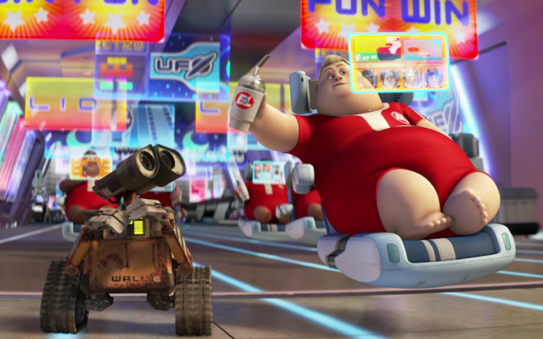I as designer want to create (mainly) simple devices and/or systems to make peoples life easy and enjoyable. With this I don’t mean a completely automated house where one doesn’t have to do anything. However, I feel like this is a future where we are heading towards. Therefore I want to design these (simple) devices/systems in such a way that we keep or highlight/improve certain experiences instead of automating it. These products either help or improve an experience, but don’t do them for you.

Figure : The type of future I want to design against (scene from Wall-E)

I also find it extremely important that the users of the product will be able to influence exactly what the product does for them and what for example data it collects. The product is theirs and therefore they should have the influence on what the product does and not the other way around where there is gatekeeping and data collection without the user actively agreeing or even knowing about it.

# Development

## Previous goals

* Explore which parts of the design process I like the most by reflecting on upcoming CBL activities.
* Explore my design interests by reflecting on general interests and (design) activities during the first semester.
* Being as open as possible for all idea’s next weeks in our CBL ideation phase.
* Staying organized while not being (too) stressed during the first semester.

In the design process I’ve noticed I really enjoy the prototyping phase. I love to come from this idea and start making physical prototypes; actually physically making the product. Therefore I also want to implement this for me as a designer, where I want to implement prototyping a lot in the design process, also in the earlier stages. Because I noticed when prototyping my brain is the most active and I suddenly envision a lot of solutions or ideas which I didn’t have before when brainstorming on paper.

I’ve learned during the last semester that I really like interactive devices and more on the electronic side in general. I realized I find it really fun and interesting to prototype the different ideas like said before. This also means for me as designer that I really want to improve and learn different prototyping techniques for different fidelities. In project 1 I’ve learned myself how to do CAD a little to be able to 3d print, however this for example definitely a skill I want to improve in further because this will make it possible for me to make different prototypes I want.

In these weeks (and also later weeks) of the design process I stayed open for new ideas, however I still believe this is a goal I have to set for myself again for next project. Since in certain moments I realized some feeling inside me just wanted to ‘defend’ a certain idea because I found it hard to change direction because I was so invested. However, this is not the attitude I should have since this really limits creativity, teamwork and the overall design process. What I did realize is that it helped for me to think that when switching ideas, the old idea isn’t gone. For me as designer I think this investment in an idea can be positive since this also makes me really motived to work this idea out. However, I have to be careful that this doesn’t limit my creativity and contribute to the team.

During the largest part of the first semester staying organized and not stressed went pretty well, especially during the first quartal. However, during the second quartal I was still quite organized however close to important deadlines like project 1 I stressed a lot even at moments where I realized it definitely wasn’t necessary. However, I somehow couldn’t really get the stress away, it just felt like everything went wrong and like I would fail everything even though I knew in my head that that (probably) wasn’t the case. This does fit my personality that I want to do everything as good as I can, I do have to learn how to control this stress because it only affects me in negative ways.

* Make it a habit to write down reflections weekly in the second quartal.
* Consciously develop my vision further by performing and reflecting on activities during the year.
* A book with writing on it

  Description automatically generatedLearn new prototyping techniques and experiment with different mediums during project 1.

I did write down reflections almost every week for a large part of quartal 2, however reflecting on it now I realize that most of the ‘reflections’ were more descriptions of what I had done that week. I’ll keep this goal for q3 with the goal of actually reflecting instead of describing in my mind, afterwards I’ll reflect on it again.

Figure : Reflection format I used during the weeks of Q2

During the first semester I went to different activities like DDW, demo day, project market etc. Reflecting on these activities as well as actively envisioning what I think the future will look like (and what I want it to) helped develop my vision further. During the rest of the year I’ll continue actively reflecting on (design) activities to develop my vision further.

Figure : Project on the DDW of the drivers of change, which made me realize I would like to design products that create an experience for the user (which fits/can adjusts for the user)

During especially the later stages of project 1 I focused on developing these different prototyping techniques by taking ownership of prototyping the final prototype and video prototypes as well as prototyping other elements together with my team. I got mainly more familiar using foam, video and 3d-printing for prototyping (see figures).

Figure : The outline of magnifying glass projector which learned me how to use both the hot wire cutter and jigsaw

Figure : Final foam prototype which learned me to use sand paper on foam to shape

Figure : Solidworks assembly of the final projector prototype

Figure : The final prototype of the projector element of our design which made me more familiar with 3d-printing

Figure : 3 video prototypes that made me more familiar with video editing for prototypes

Figure : My first solidworks part created following a youtube tutorial to learn the basics of solidworks

# (New) Goals

* Staying conscious about when I get in tunnel vision during the design process to reflect on whether I should explore other ideas during project 2.
* Document every important activity in project 2 in quality.
* Implementing prototyping and personas early in the design process in project 2.
* Stay conscious about my behaviour in my team in project 2 by reflecting (at least) every month to make sure I’m both not talking too much or taking too much responsibility.
* Improve in 3d-modelling and connecting it with electrical components to make working prototypes that are a higher fidelity in project 2.